**FORMAL NOTICE Interior Staining**

**PREMISES: 89 CAMORTA CLOSE KINGS PARK DATE: 27 June 2024**

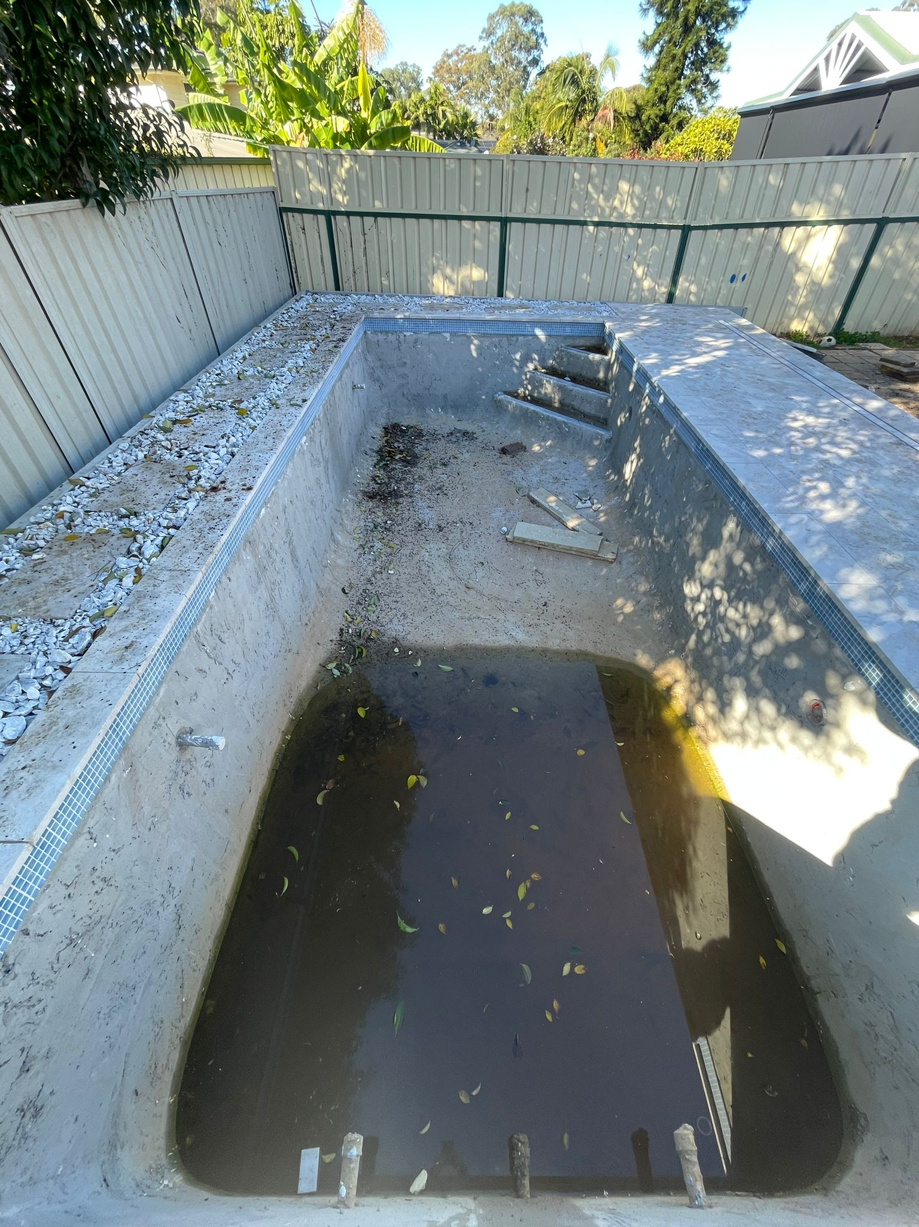

**Major Issues know to directly affect a pool interior lining**

* Interior Staining
* Stagnant water, rubble, metal, leaf tannin and debris collected in shell to be removed during construction.
* Timber, stack stone, external hosed debris leaching onto or into pool results in future surface staining of pool finishes

# Your Obligations - Interior Lining

Prior to interior lining application of any type of interior lining (ie. pebble or glass beads), ensure that all surrounds are sealed to avoid loose soils, dirt, vegetation or mud to enter the fresh lined pool or body of water. It is recommended that all surrounds be clean prior to lining the pool to avoid brown spots and staining containments.

It is the Customers obligation to inspect the pool shell at time of handover and earmark any surface staining. If no staining is reported it is assumed there is none present and the surface will remain under the responsibility of the Customer

The customer loses the benefit of the warranties if:

1. Staining is caused by a failure to correctly maintain the pool, including maintains the correct chemical balance
2. Or water used to fill the pool from hose or tanker causes staining
3. Failure to diligently remove stagnant water, rainwater, rubble, metal, leaf tannins, rubble, vegetation and external matter or runoff during the construction period prior to handover
4. After Handover, failure to scrub pool walls with regular brushing to prevent calcium build up or diligence to follow material manufacturers care recommendations

OTHER RESOURCES:

[After Sales Care - Blue Haven Pools](https://bluehaven.com.au/pages/warranty/)

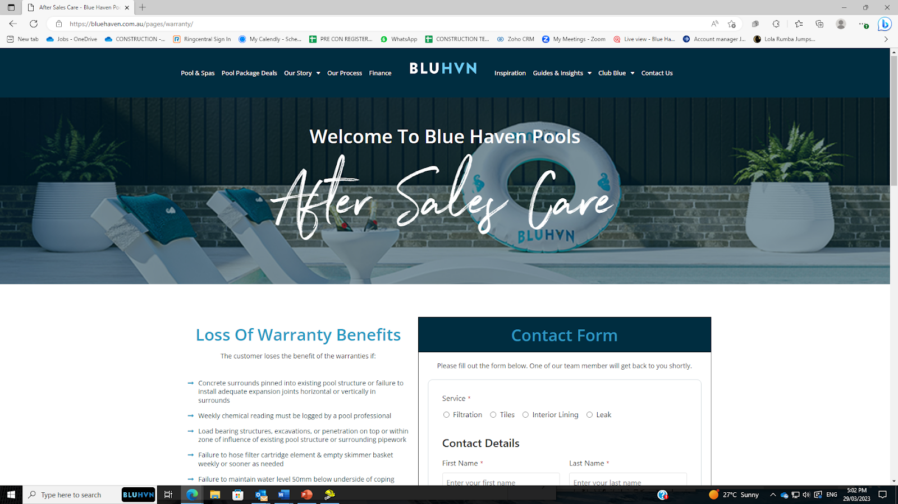

[Fact Sheets | Blue Haven Pools and Spas](https://bluehaven.com.au/guides-insights/fact-sheets/)

**BLUE HAVEN POOLS HEAD OFFICE 68 HUME HIGHWAY LANSVALE NSW 2166**