|  |
| --- |
| Stage 2 Pool Finishes  **Quotation** |

|  |
| --- |
| Price  **$23,480.00\***  **\*Terms, Conditions and Exclusions apply** |

|  |
| --- |
| Price valid for  **30 days**  **Issued on 21/08/2023** |

|  |
| --- |
| For: **EMMA MCTAGGART**  Site Address: **7 THERRY STREET, AVALON BEACH**  Owner Contact: **0419 628 612**  Reference Number: **21S6322** |

|  |  |
| --- | --- |
| **PACKAGE SUMMARY** | |
| **Tiling:**   * Laying of Coping Pavers * Laying of 150mm Waterline Tiles | OPTIONAL V-LOCK PREMIUM TILED SKIMMER LID | $550.00 |
| **Interior:**   * PURE HAVEN WHITE PEBBLE INTERIOR | RECOMMENDED | ADD GLASS BEADS TO INTERIOR PEBBLE (+) $1,190.00 |
| **Equipment:**   * Efficient 1.0HP Pump for pool filtration * LARGE Opal 180 Cartridge Pool Filter * Resuscitation Chart & Manual Cleaning Accessories * Mineral Magnesium Water | * start Up Chemicals * (2) x Multi Colour Pool Lights |
| **Other Services:**   * Running Pool Plumbing Lines to nominated filtration location. * Handover with Technician * Home Owners Warranty Insurance | SHELL TO BE IN ACCEPTABLE CONDITION PRIOR TO FINISHING WORKS |  CHEMICAL POOL WASH (+) $1,490.00 |
| **Package Price $23,480.00\*** | |
| **\*Key Exclusions:**   * Supply of tiles, glue and grout materials are not included. * An electrician is required to supply power at nominated filtration location and earth the pool. * Temporary and Permanent Pool Fencing is not included. * Void Cover removal, shell dewatering, preparing the site for pool works is not included. * Equipment enclosure is not included. Recommended supplier; [www.acousticbox.com.au](http://www.acousticbox.com.au) | * Landscaping works including the tiling of exterior pool shell, digging trenches for pool plumbing lines and boundary fencing are not included. * RECOMMENDED ADD-ONS ARE NOT INCLUDED BUT ARE OPTIONAL FOR OWNER TO ADD TO PACKAGE. The listed (+) $ price is in addition to package price. * HOME OWNERS WARRANTY INSURANCE is a requirement for construction programs over $20,000.00 in value. |
| **Important Information:**  This is a quotation only and does not constitute a formal contract or any agreement between the parties to undertake finishing works on the shell.  A formal binding contract is required to be entered into based on the agreed inclusions. Price, exclusions and timeline are subject to the terms and conditions outline therein.  Price, Construction Timeline, Inclusions and Exclusions are subject to the terms and conditions of a binding Stage 2 Pool Finishes Contract. The finishes contract price is valid for 12 months from date of finishes contract being agreed to. Re-entry into the construction program is not permitted in the period of September – December.  All quotations are GST inclusive. | |

|  |  |  |  |  |  |  |  |  |  |  |
| --- | --- | --- | --- | --- | --- | --- | --- | --- | --- | --- |
| |  |  |  |  |  |  |  |  |  |  | | --- | --- | --- | --- | --- | --- | --- | --- | --- | --- | | **Ready to proceed?**  Now’s the time to make your payment and lock the price in for 12 months.  Provide us with a timeline for when you can manage key exclusions so we can reserve your placement in our construction program to arrange tiling, equipment installation and pebbling.   |  | | --- | | **PAY NOW: $23,480.00** |   **How to make your payment:**   |  |  |  |  |  |  |  | | --- | --- | --- | --- | --- | --- | --- | | *Make an EFT Payment*  **Your reference number #** **21S6322**   |  |  | | --- | --- | | **Account Name:** | Blue Haven Pools South | | **BSB:** | 062-195 | | **Account:** | 1021-8030 | |   OR   |  | | --- | | *Pay by card* over the phone.  **Call 02 9728 0444, option (3)**  2.5% surcharge applies to all payments made over the phone by card. | | |

1. TILING:

Example Photo showing V Lock Hideaway Skimmer, 150mm Waterline Tiles and Coping Lay.

Mosaic Strips along the steps are also shown in this image as an optional extra charged at $150.00 per lineal meter.

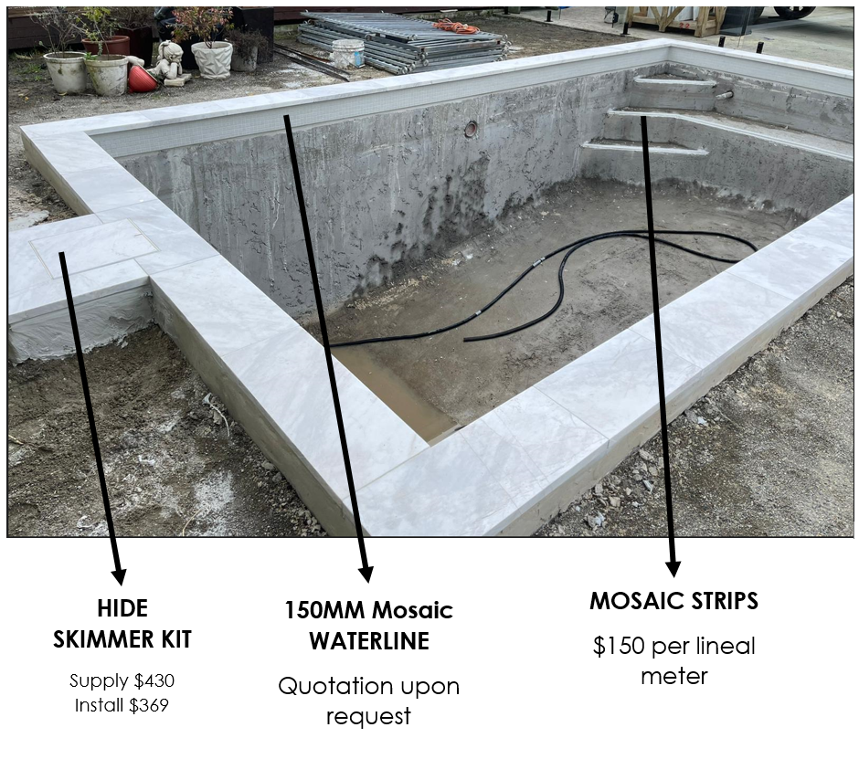

**V LOCK TILED SKIMMER**

1. INTERIOR:

The interior selected as part of this finishes package is shown below:

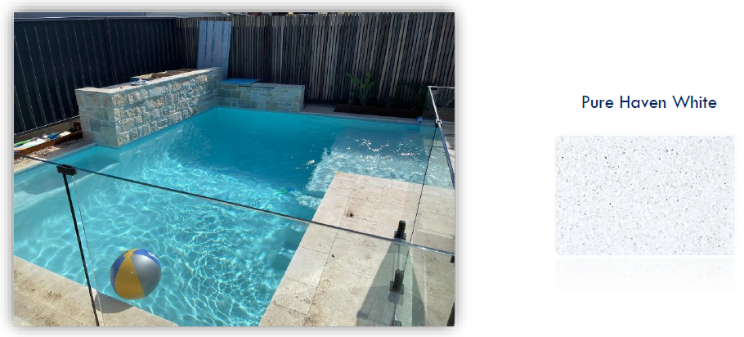

Option to add Blue Glass beads to pebble interior for (+) $1,190.00

