

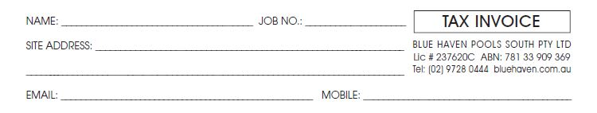

**THIS CONFIRMS YOUR AGREEMENT TO AUTHORIZE BLUE HAVEN POOLS SOUTH P/L TO OBTAIN BELOW DOCUMENTATION ON YOUR BEHALF:**

|  |  |
| --- | --- |
| Planning Certificate Issued Under Section 10.7(2) |  |
| NSW Land Registry Services – Title Search |  |
| NSW Deposited Plan |  |
| Additional Items (If Applicable) |  |
| * Sewer Peg out Report / Service Protection Report | $750 |
| * Backyard Survey ($800) / Full Detail Survey (P.O.A) |  |
| TOTAL (Inclusive of GST) |  |
|  |  |

The above activities do not constitute residential building work as defined by the home Building Act 1989. The documentation obtained by means of this Consent form, become the property of the customer once obtained. The Customer Understands and accepts that if formal agreement(s) are not proceeded with, (if any), monies paid under this Consent form are Non-Refundable.

