**HANDOVER PROCESS FOR THE POOL**

Once the interior for the pool has been completed, the status would be changed to handover in the construction google sheet as well as poolz. Please make sure you inform the team to invoice the client for handover. Once the client has paid his payment 5 you need to do the following.

Steps after Payment 5 is received.

1. Go to Poolz.
2. Go to reports (it is located on top of modify on the customer details page of poolz)
3. Click on Reports. And then click on construction.
4. Click on customer details.
5. It is will show print report like this

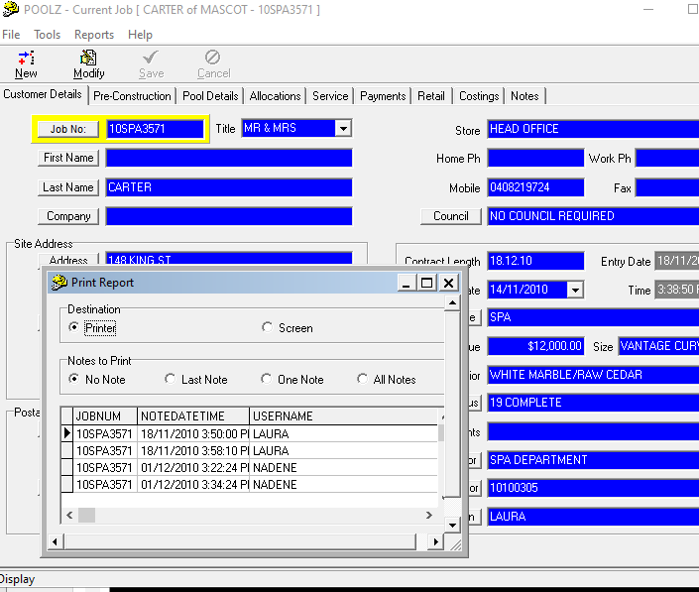

1. Click on screen to get the customer details saved on screen for you.

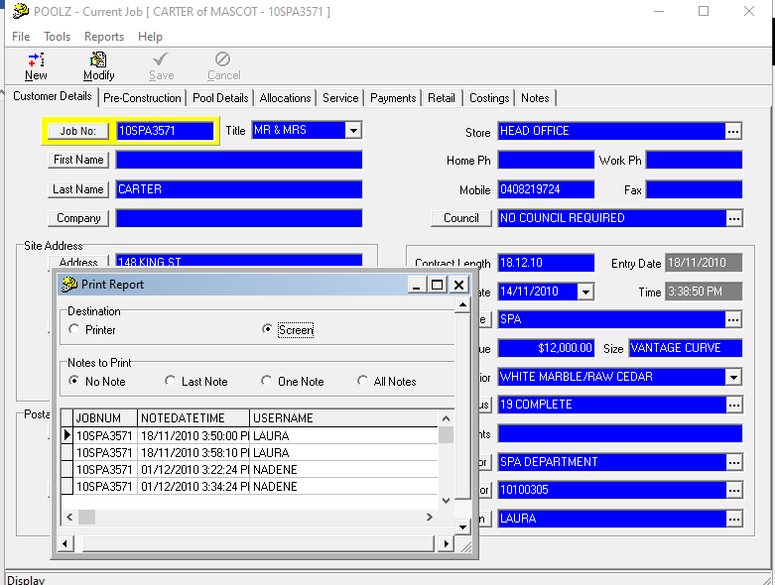

1. Once clicked on screen scroll down and click on print.

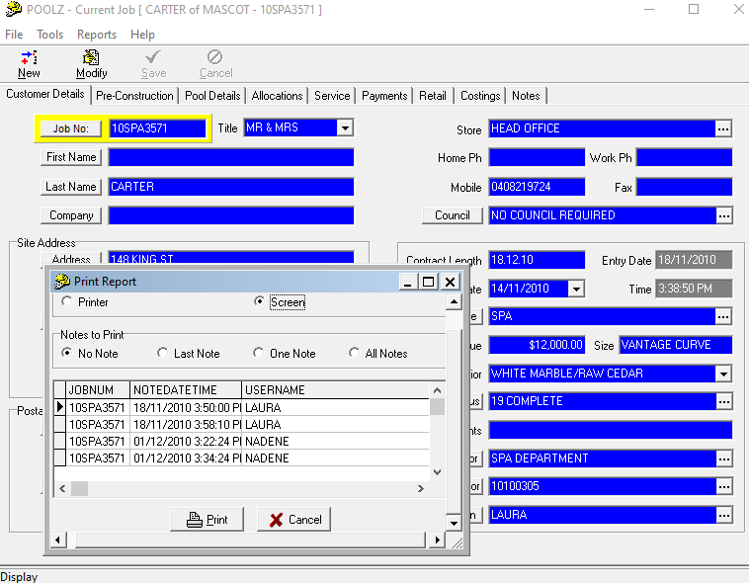

1. Once you click on print you will see all the customer details like this.

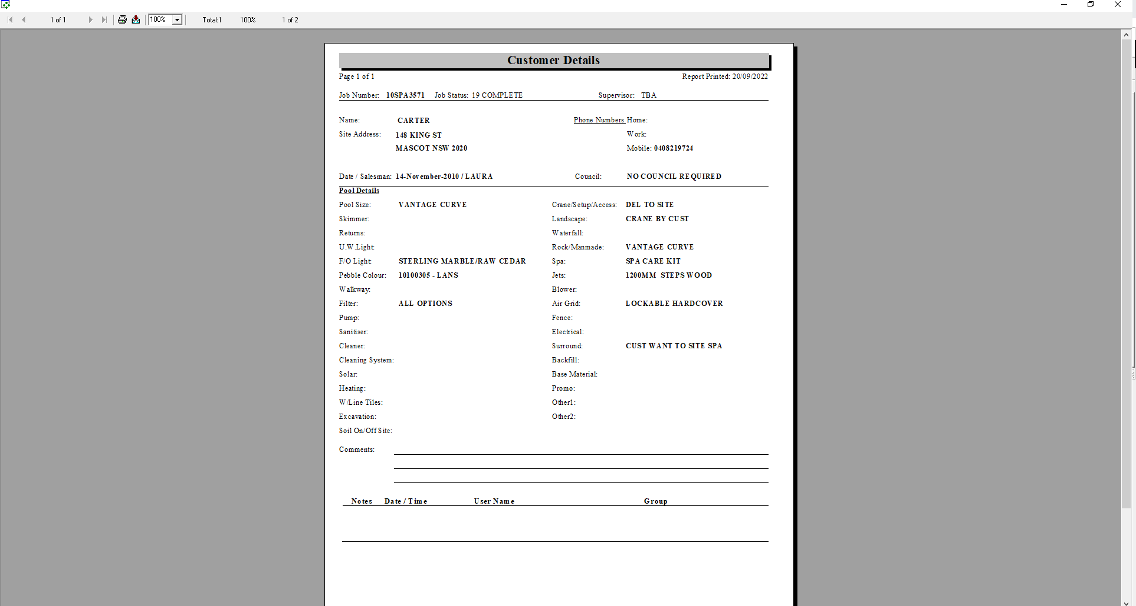

1. Take a screenshot and save the customer details.
2. Once saved you will have to save the handover sheet.
3. Go to poolz.
4. Click on Allocations.
5. Scroll down and you will see handover
6. Click on modify button on top.

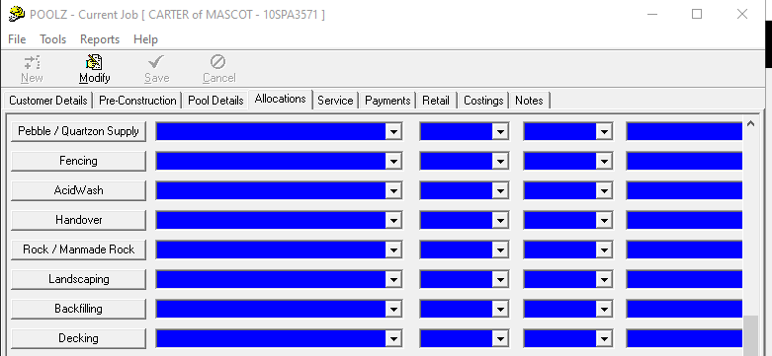

1. Scroll at the bottom and go to handover.
2. Once you go to hadover use the scroll down arrow on the right hand side and click on paperwork.

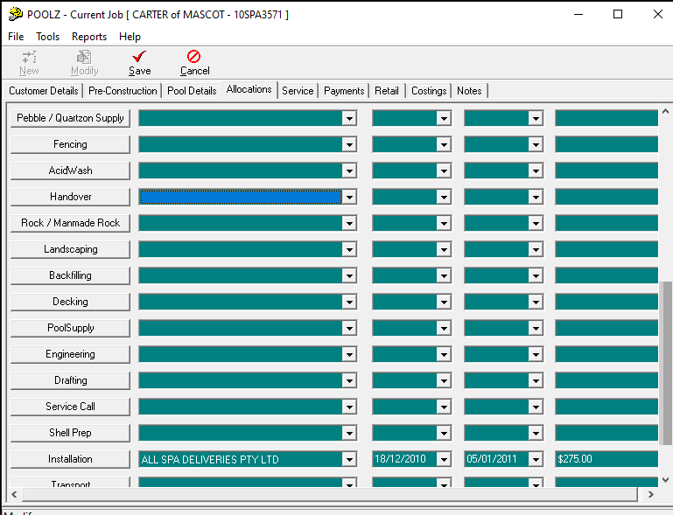

1. Click on the save button on top next to modify and save.

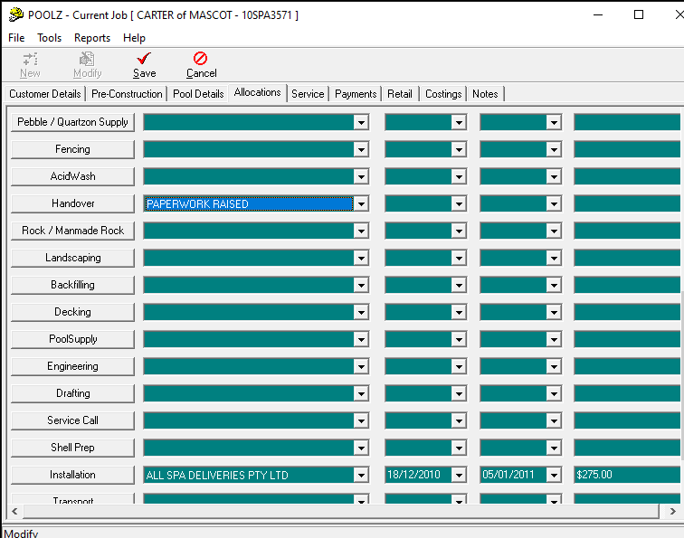

1. Save the paperwork.

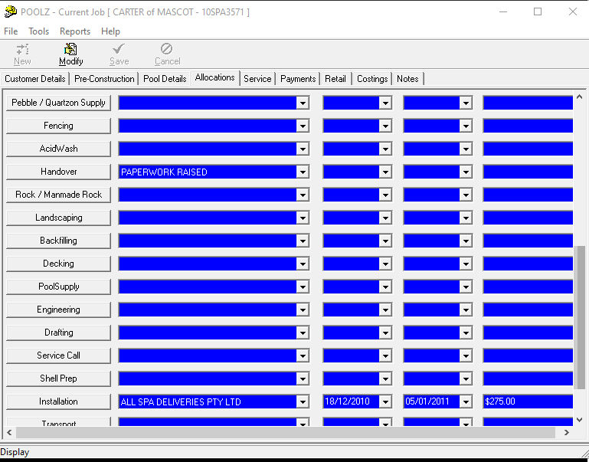

1. Once saved you would be able to save the handover sheet.
2. Go to Reports on top of modify.
3. Go to construction
4. And then click on handover
5. Once you click on handover this tab will come on your screen

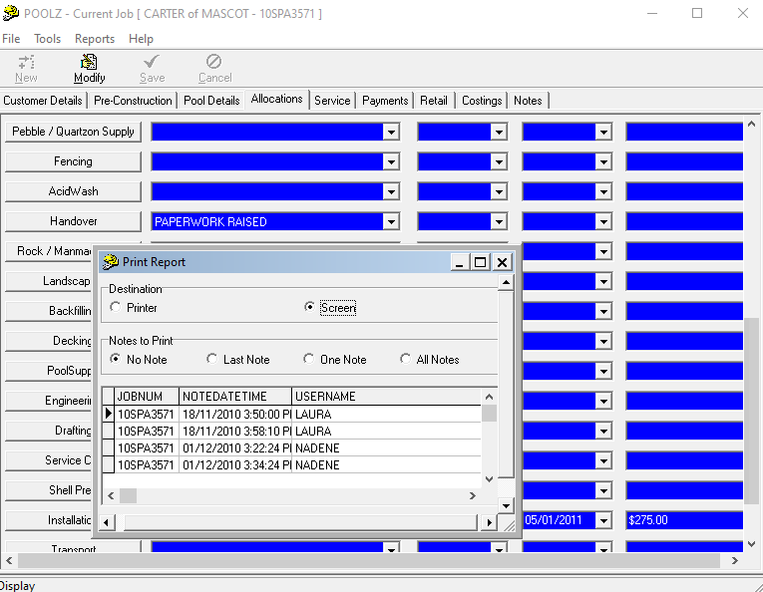

1. Click on screen.
2. Scroll down and print.
3. This sheet will be on your screen
4. Use snipping tool or screenshot it and save it in jobs folder. Make sure you check it has all details.

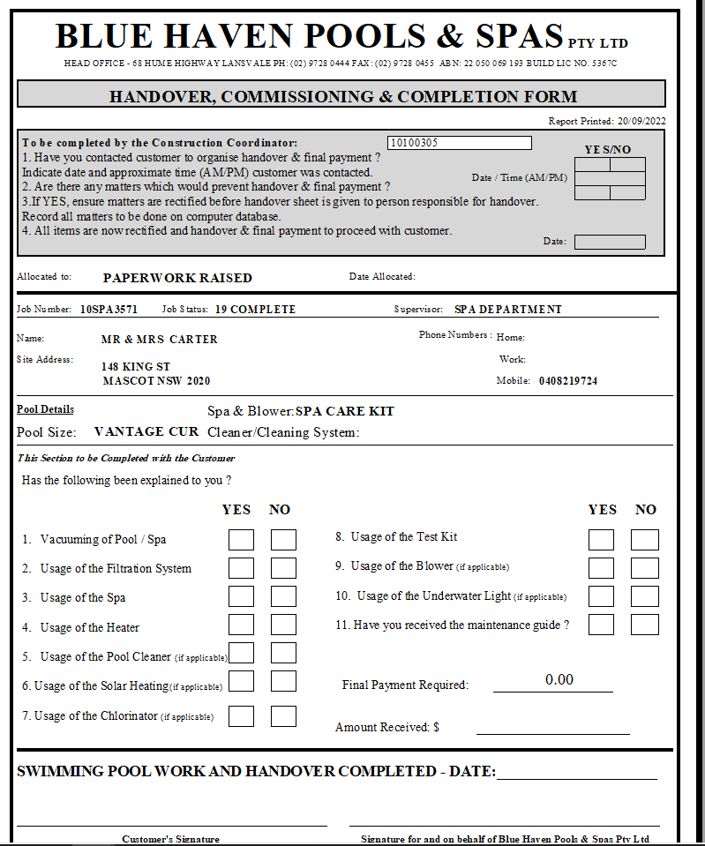

1. Once done then you can send it in the whatsapp group to the handover man you are allocating to.
2. If eg you are allocating it to glenn. Send the customer details and handover sheet on glenn’s whatsapp wall.
3. If you are sending it to kyle or Mitchell do the same.
4. When you send it through make sure you write the full address i.e. street address and suburb for them to book in the handover for the client.
5. Once done glenn will post the pictures on whatsapp after handover is completed.
6. Check in pools. Go to pool details if they have mineral sanitiser.
7. Once the handover is completed the client has to be booked for mineral setup for 4-5 weeks after the handover date.
8. Check with glenn when you are close to mineral setup for the pool and send the customer details sheet again in glenn’s (eg) whatsapp group and let him know to book a mineral setup.
9. DONOT FORGET to write the street address and suburb at the bottom before sending it through.

That’s usually it for handover. Once the handover is completed we need the client to be booked in for the Final Inspection for Occupation certificate.

**What is Occupation Certificate?**

Final occupation certificate is a final certificate required from the private certifier or council (any approval body) to give an authority in the form of a document that the pool is built accurately and they can now use the pool. Unless the pool is not registered THEY CANNOT USE THE POOL.

There can be two things that you need to know for the final occupation certificate before it is given.

1. Have we done the approvals for the client?
2. Or did the client do his own approvals?

To check who did the approvals for the client. you have to go to the poolz system. Click on preconstruction and then click on total fees. The certifier’s name is usually written on the total fees to know who did the certification for the pool.

If in case you cannot find it there go to jobs folder and then digital supervisor file folder. And then go to the stamped plans pdf. Click on that and the stamp should have the certifier’s name.

The certifiers that we usually work with are AVOCA/ NEMCO, Certicorp, North coast, East coast approvals.

If they have approved the plans they mostly BHP did the lodgements.

If bhp has done the lodgements we have to do the Final Occupation Certificate for them.

**Steps for Final Occupation Certificate:**

1. Once the pool is handed over check the following things with the client.

* Is the equipment enclosure done. Equipment should be covered. Make sure only pump, filter and sanitiser should be under enclosure and NOT HEATER. Heater can be next to the equipment but it should not be covered.
* Is the fence is up? Is the permanent fence or any complaint fence completed.
* Is the pool working alright. Incase there is any warranty issue.

1. If the client says that they have completed all of the above, send them the email as stated below.

*Hi xx,*

*Hope this email finds you well. I am writing this email in regards to the Final Occupation Certificate. I have attached the list of documents that are required from your end to book a inspection with the certifier. It would be great if you could please fill and send the documents back to me at your earliest.*

***Documents for final occupation certificate :-***

* OC Application Form - owners to fill out and sign - (attached in the email)
* Glazing Compliance Certificate - if an internal glass fence - by fencing company
* Electrical Compliance Certificate to AS 3000 Wiring Rules - by Electrician
* Swimming Pool to be registered on NSW Registry - Link - <https://www.swimmingpoolregister.nsw.gov.au>

Please contact us if you have any questions. Thanks. Hope you have a good day!

1. Make sure you attach the application form for the client to fill out. Let the client know that they have to register their pool at the NSW Registry. They will receive a document attached below which they have to send it to you so that you can provide it to the certifier.

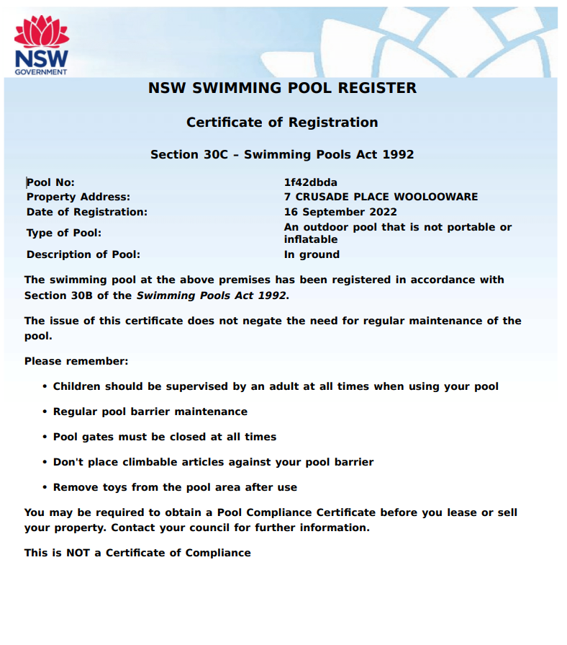

1. Once you have all the documents from the client, you can send it to the certifier who approved the pool plans i.e certified the pool for the client.
2. Sometimes certifiers also ask for water recirculation certificate. We usually provide that certificate to the client. Attached a screenshot for you. I have also attached the template in the email

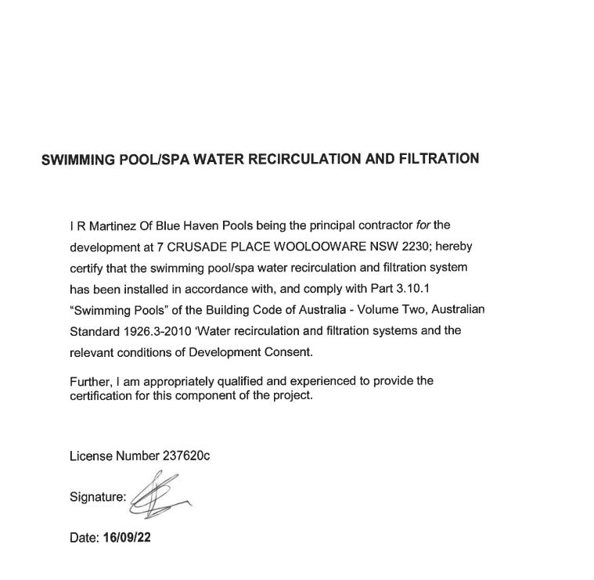

Make sure you ask Remonda before putting in a signature or Remonda will let you know about signature.

1. Sometimes certifiers also ask for the plumbing certificate. You have to ask adam to sign it for you.
2. Once you have all the necessary documents that the certifier requires please send it to the certifier to book in an inspection. Ask the certifier for a date as to when he is going to go to the site to do the inspection.
3. Sometimes the certifier just get photos from the client and approves the pool if he has visited the site during fencing stage. That is fine as well. just make sure you have a Final Occupation Certificate from the certifier. \

**What if the certification was done by the client?**

1. If the client had lodged the plans then they will do the certification for the pool.
2. In these case all you need to do is ask the client when is the inspection booked for?
3. Sometimes the client can ask for water recirculation certificate and plumbing certificate. We can provide that to the client.

**Documents that are required for final oc. And why they are required?**

The documents like Glazing certificate, Nsw Registry, Plumbing certificate, Pool enclosure certificate etc are required by the council. Reasons listed below.

1. Glazing Certificate – to check if the fence is done as per the Australian standards by the fencing company. Client usually gets the certificate from the fencing company.
2. Electrical Certificate – to check if the electrical works are done as per Australian Standards. Client usually gets this from the electrician.
3. Enclosure certificate – client has to do their own certificate for this.
4. Plumbing certificate – by blue haven team. To check if the plumbing is as per Australian standards. BHP does this. Template attached in the email.

Usually that’s what the certifier asks for to provide the Final Occupation certificate.