**BLUE HAVEN POOLS SOUTH PTY LTD**

**68 HUME HIGHWAY, LANSVALE**

**02 9728 0444**

**ABN: 78 133 909 369**

Date:

**FORMAL NOTICE**

**Temporary Fencing and Compliance**

**SITE ADDRESS:**

**REFERENCE NUMBER:**

**CUSTOMER NAME:**

**You are to maintain the “NO ACCESS” signage on your temporary fence and ensure no access is available into the pool site from the front OR backyard.**

Temporary Pool Fence installation should be installed in compliance with regulations, be fixed and restrict access to the pool site.

**SITE SAFETY -**Safety and fencing codes must be maintained by Customer

**HOME OWNERS WARRANTY**

On Handover Blue Haven Pools will inform insurance that pool is completed and no further works will be carried out by Blue Haven Pools

**COMPLIANCE**

Customer will now be responsible to follow the compliance codes when completing the pool and surrounding areas. Including booking final inspection and receipt of final occupation cert.

**CONCRETE SURROUNDS**

Customer will not pour concrete works within the zone of influence to the pool or pipework and understands this may impact on the pools structural integrity. Customer is to consult an engineer prior to doing any such works including concrete surrounds or any load bearing structures. It is not acceptable to pour a concrete slab for pool fence footings directly in the zone of influence to pool or pipework without following correct standards as two different concrete structures will shrink and contract at different rates and may severely affect the integrity of the pool

**FENCING**

**Customer will not instal a fence directly on the pool coping**

**Customer is fully responsible to earth any glass fence spigots within 1.2m of the pool area unless they are non-conductive**

**Your Obligations – Final Inspection and OC**

Our records indicate the completion of your pool contract is awaiting a pool fence so Blue Haven can complete the pool interior and water filling. In most cases this work cannot be carried out without a permanent pool fence erected.

However, you could seek advice from your Private Certifier as they are the party who can issue a Certificate of Compliance under Section 22 D of the Swimming Pools Act 1992.

Section 22 D of the Act suggests the Certifier ‘may grant exemptions from barrier requirements that are impracticable or unreasonable in particular cases’.

It is important to understand that if you proceed to finalize the swimming pool contract with water and handover our attendance to site finishes and you are the party entirely responsible for the safety matter and in the occasion of serious injury or death due to water in the pool, the liability imposed on you by law may include fines or imprisonment.

Whilst many people do fill pools prior to final OC, it is important to understand the risks and be fully prepared to secure the area until the permanent fence is installed and final occupation certificate issued.

Once your pool fence is up you should book the final inspection, register the pool with council and obtain the final OC without delay. If you wish to proceed with filling the pool and finalizing the contract with Blue Haven Pools, please sign and return this notice.

I fully understand the risks and obligations that I have as the Home Owners pertaining the safety fence as required by law and request Blue Haven Pools to complete the pool works contracted and accept all liability in any matters that may arise from Council or Local Government or other.

**FENCING**

Customer will not install a fence directly on the pool coping.

Customer is fully responsible to earth any glass fence spigots within 1.2m of the pool area unless they are non-conductive

**Owner Signature: ______________________**

**Date: _______________**

**Major Fence Issues known to directly affect compliance & OC**

* Non-compliant footholds along Boundary fence
* Non-compliant footholds along Pool fence
* Hand-holds or Footholds within 900mm of the top of the pool fence in any direction.

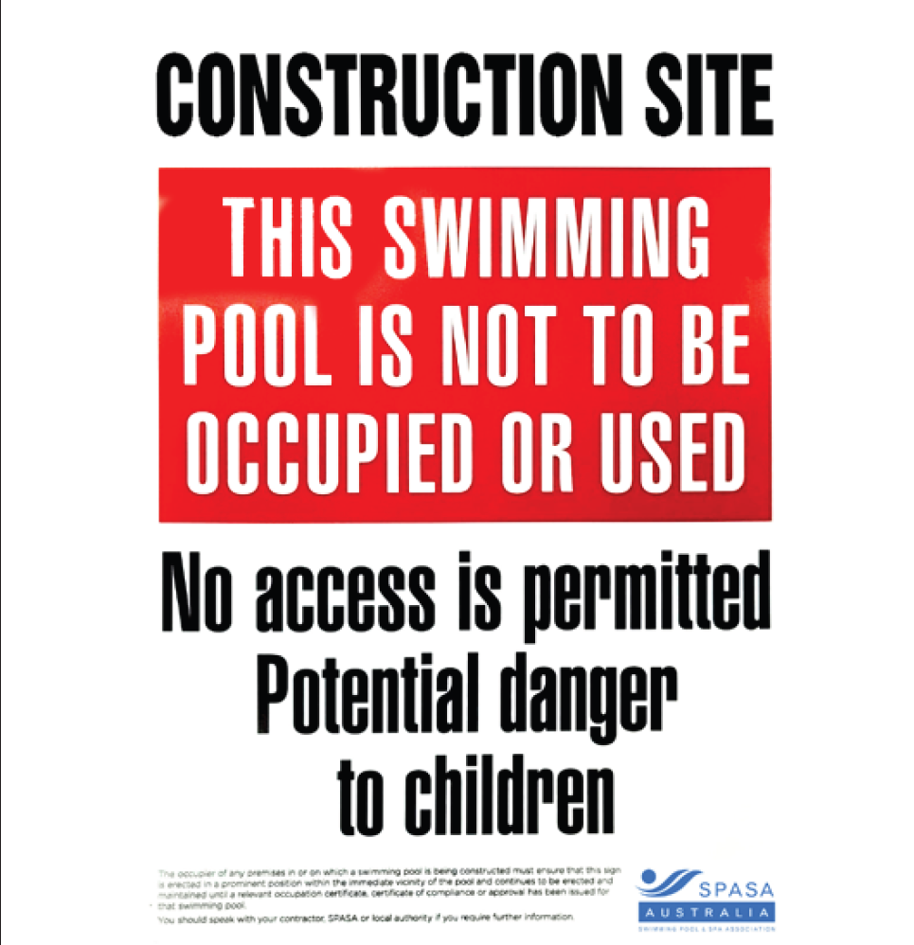**Other Comments / Notes by Builder (Blue Haven Pools):**

The image above is the No Access signage that should be maintained on the temporary fencing.

**Additional Sources of Information:**

[**https://bluehaven.com.au/pages/warranty/**](https://bluehaven.com.au/pages/warranty/)

You can learn more about pool maintenance and loss of warranty benefits on our website. Link has been provided above.

[**https://bluehaven.com.au/guides-insights/fact-sheets/**](https://bluehaven.com.au/guides-insights/fact-sheets/)

We have an amazing Fact Sheet Library online where you can learn more about pool finishes, do’s and don’ts and making selections. The link has been provided above.

**Construction / Finishes Contract**

Your construction or Finishes contract outlines owner and builder responsibilities, contract terms, and scope of works.